In this lesson we are going to installs and setup unity so that we can start working with it
So you first go to Google and then search Download Unity
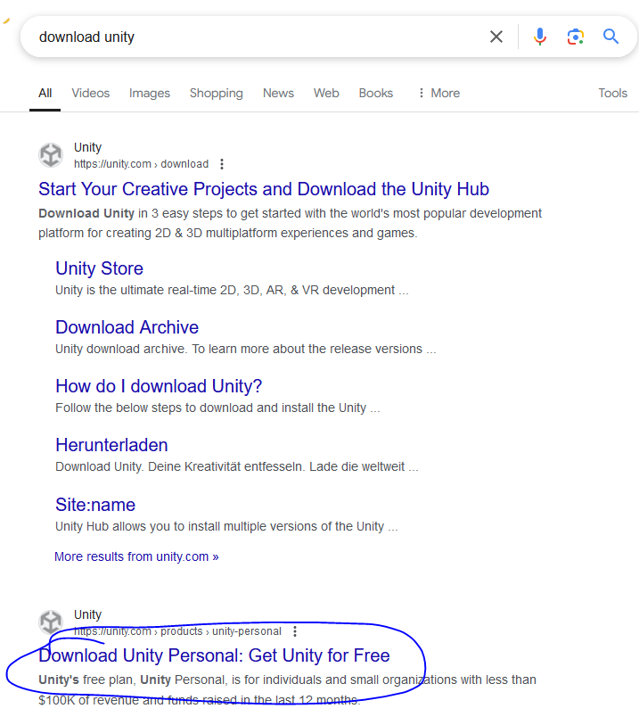
and then click on the link marked as above
or you can go to Unity3d.com(according to Teacher) but it is showing Unity3D.com
Make sure you have unity account because it is needed to activate the license
and then download Unity hub
and then install it Now we will open it
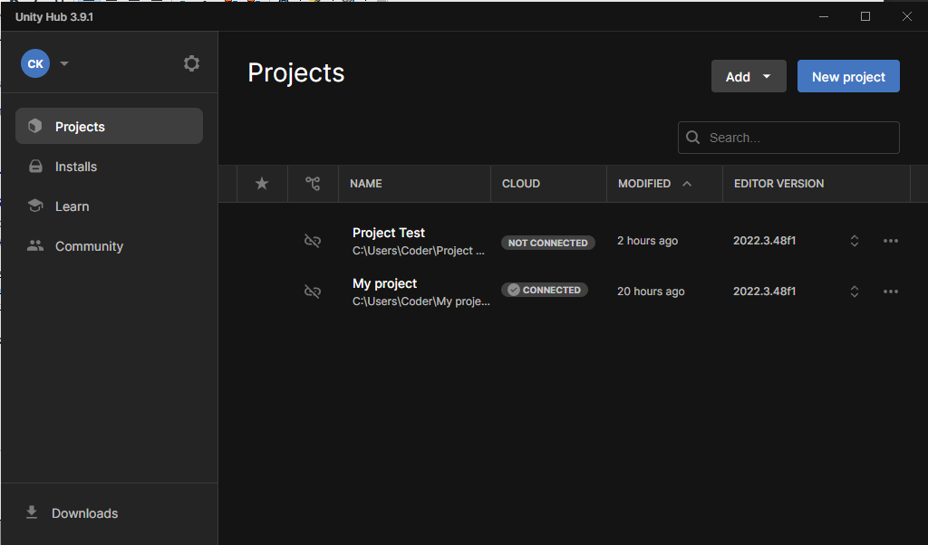
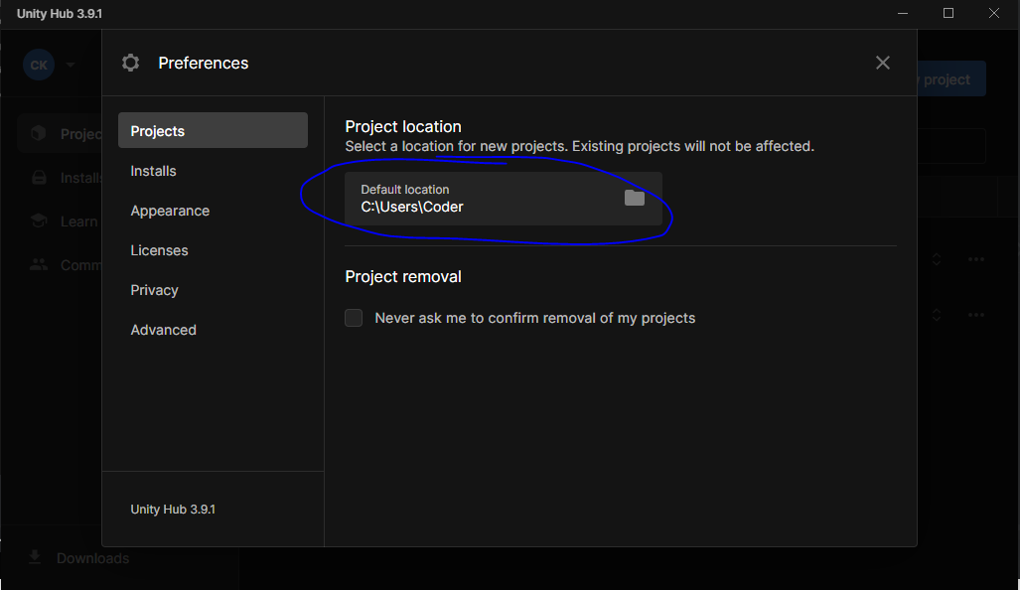
Upper screen image shows how our unity hub will look
Now go to Installs tab and from here you are going to install the latest unity version.
Now you can see a gear icon above the Projects side tab.
Now a new mini window will open and in projects side tab we can set the project default location
as marked above
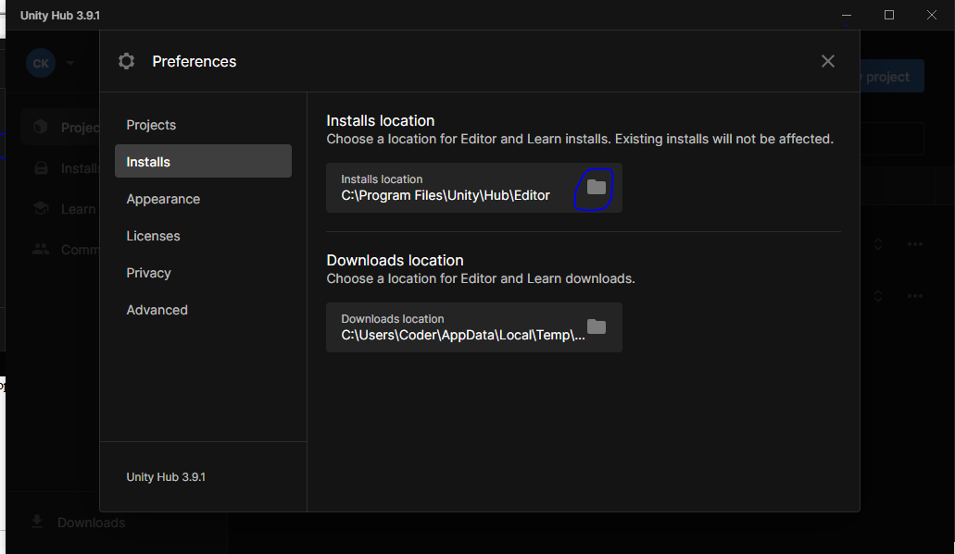
Now in Installs side tab you can set the location where your all the installs are kept.

If you want to change the default location then click on browse button as marked above then
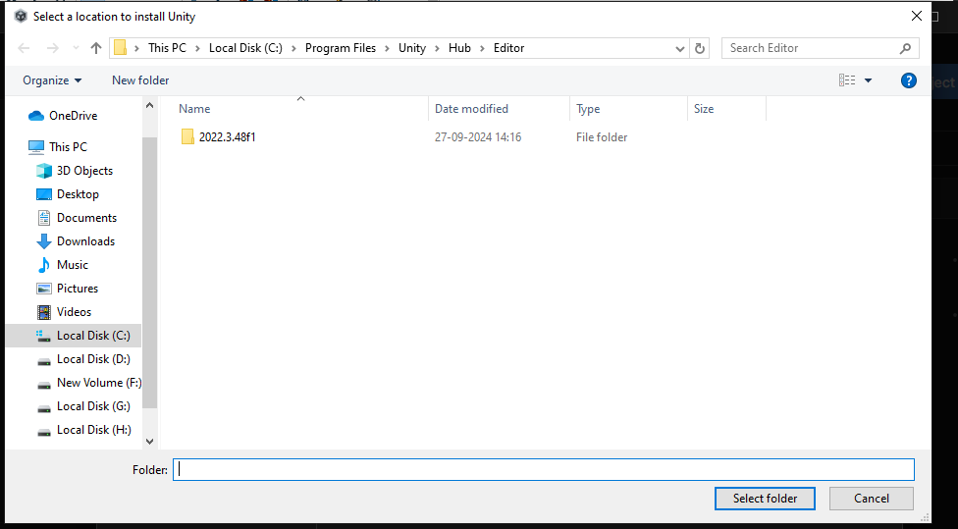
a browse folder will be opened choose the location you want.
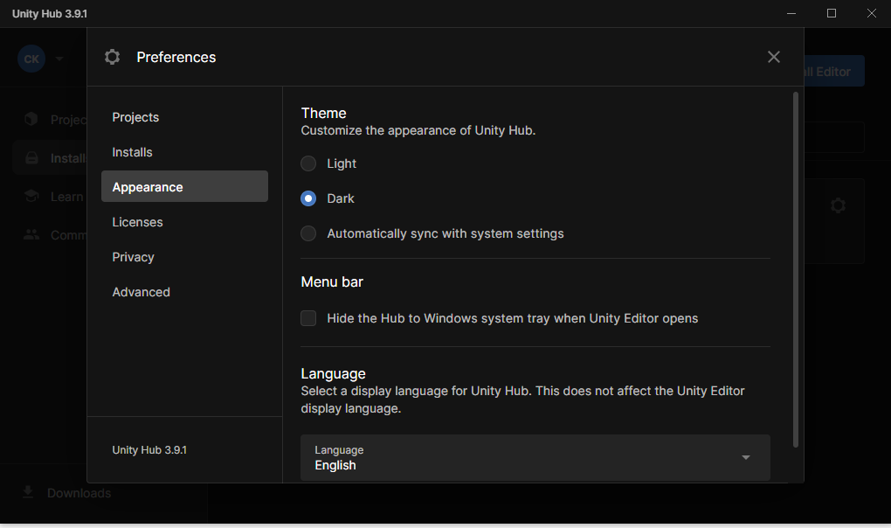
Now in appearance side tab you set the appearance of Unity hub.
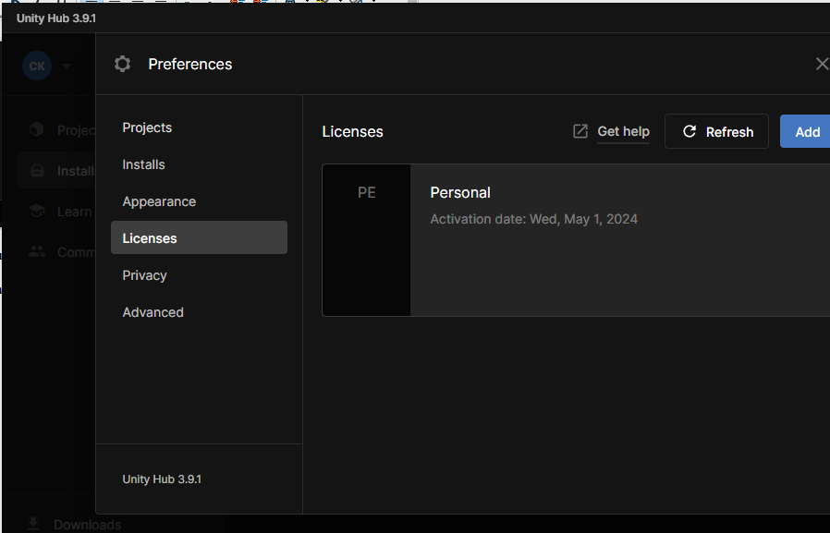
And in License side tab you can see all your license and get them if you have Unity Account.
Now after closing Preferences
go to Installs side tab

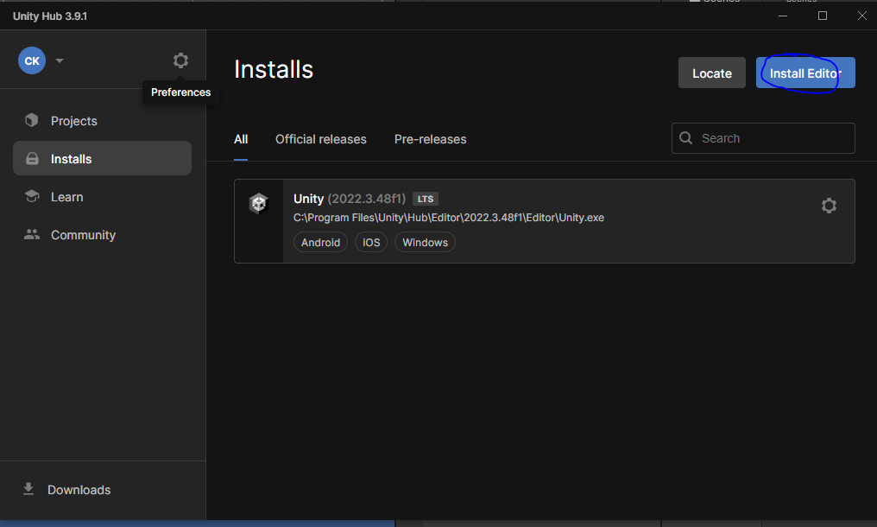
and then you can choose Install Editor button a new mini window will be opened like below
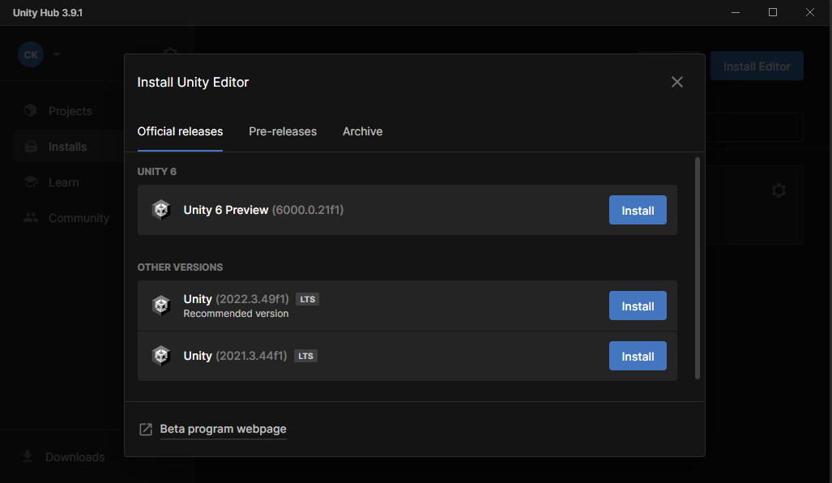
and then choose the latest version of unity or you can choose the lts version
These are the version where unity will provide you support even after they become old.
In pre- releases tab you can choose the beta or alpha version for our upcoming version
Teachers don't recommend us this but you can use it for testing purposes.
So go to official releases and then you can install by clicking on the install button respective of the version you want to install
Now you will get the components that you need to install like below
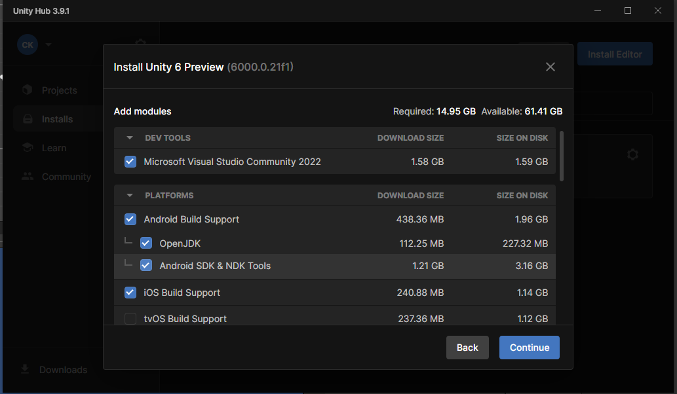
Microsoft Visual Studio is the default code editor you need to code your game
Now for android suppoer we check the Android Build Support
For IOS choose IOS Build Support
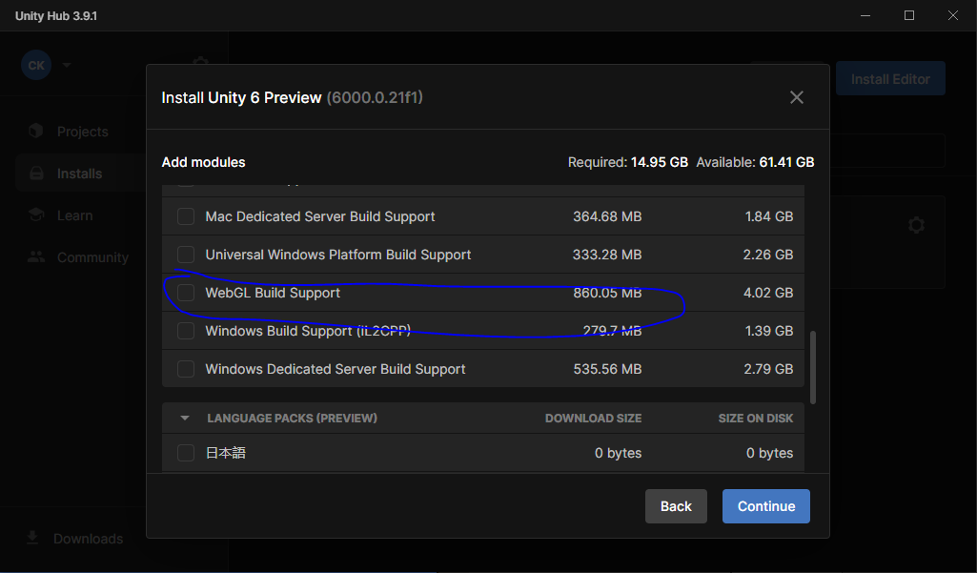
If you want to make game for web then you can choose WebGL Build Support
and we also have documentation but we can see it from Unity Website
Now after choosing everything you want click on continue button
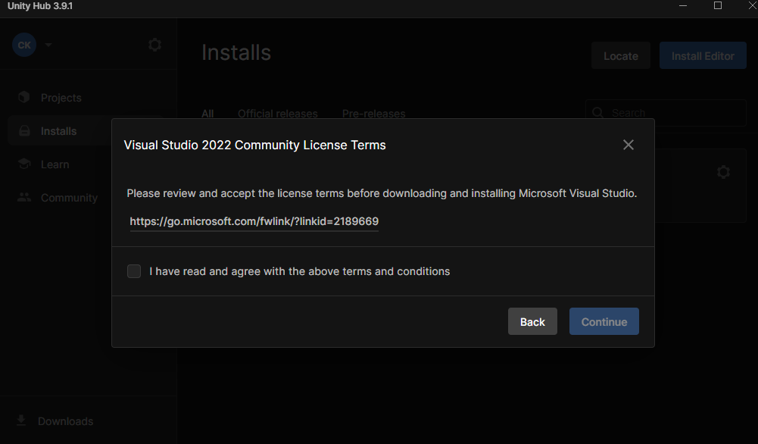
Then accept the licence and then click on continue
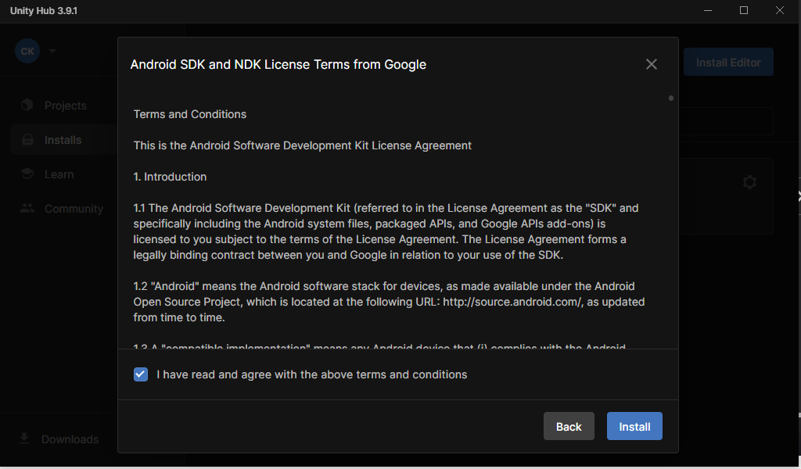
And then again accept the agreement and then click on Install button
and now the unity version will be installed on your local computer
Now to create a new project go to project sidetab
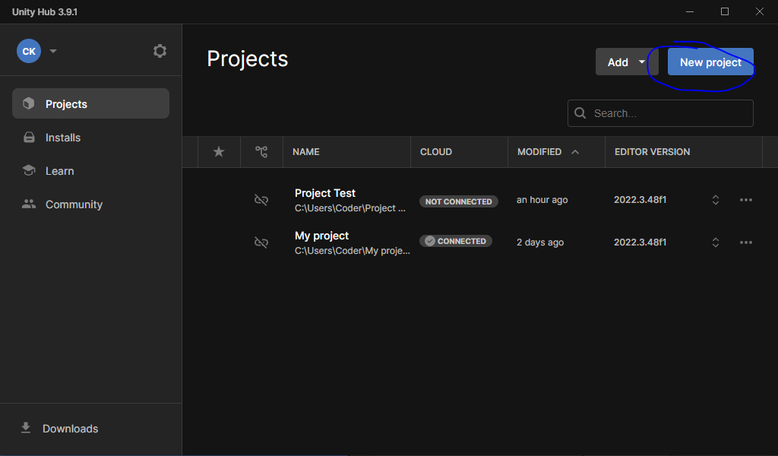
and then click New Project
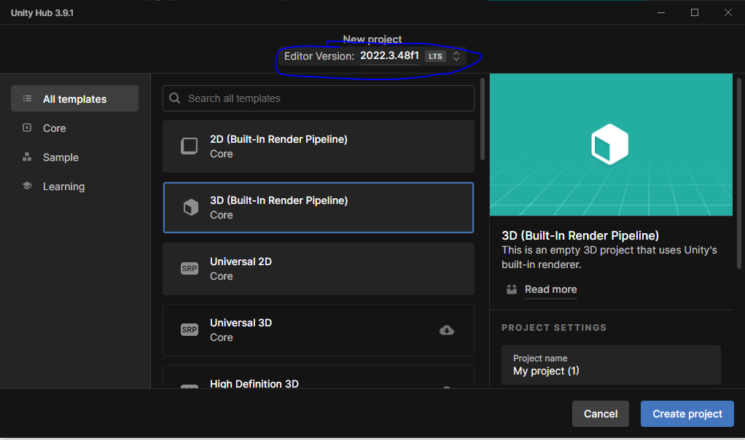
and a new screen will appear and from the marked area choose the esditor version you want to use
and now in the list below the marked tell the type of project you want whether you want to choose the 2D or 3D project
i choose 2d (Built in Render Pipeline) for my 2D project for 3d iwill choose 3D(built in Render)
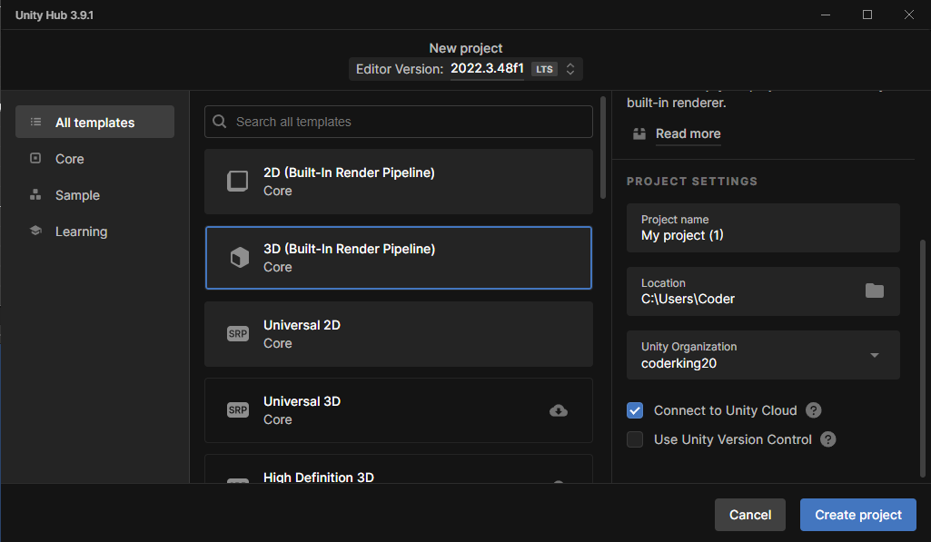
in the right side type Project name,location where you want to keep your project here it is set by default by the preference. After this click on create project and our new project will be created
And now in next section we are going to start building our game with unity

